Supervised Learning Model Implementation
Classification of Breast Cancer Diagnosis
Using the Wisconsin Breast Cancer (Diagnostic) Dataset
Week 4 Task Report | Yuva Intern – Virtual Data Science Internship

1. Introduction and Objective
This report documents the complete process of designing, implementing, and evaluating a supervised learning classification model for a medical diagnosis problem. The goal is to predict whether a breast tumor is malignant or benign based on features extracted from digitized images of fine-needle aspirates (FNA) of breast masses.
The task aligns with the requirements of the Week 4 assignment: selecting a public medical classification dataset, performing data preparation and feature engineering, training models using Scikit-learn (and XGBoost), validating via cross-validation, evaluating with appropriate metrics, and discussing strengths, limitations, and possible improvements.

2. Problem Definition

2.1 Problem Statement
Breast cancer is one of the most common cancers among women worldwide. Early and accurate diagnosis is critical for effective treatment. This project frames the problem as a binary classification task:
- Input: 30 numeric features computed from cell nuclei present in a digitized image of a breast mass FNA.
- Output: Class label – Malignant (0) or Benign (1).

2.2 Dataset Description
Dataset: Breast Cancer Wisconsin (Diagnostic) Dataset from the UCI Machine Learning Repository (available via Scikit-learn).
- Number of instances: 569
- Number of features: 30 numeric predictive attributes
- Class distribution: Malignant = 212 (37.3%), Benign = 357 (62.7%) – mildly imbalanced
- Features: Mean, standard error, and “worst” (largest) values of 10 characteristics of cell nuclei (radius, texture, perimeter, area, smoothness, compactness, concavity, concave points, symmetry, fractal dimension).
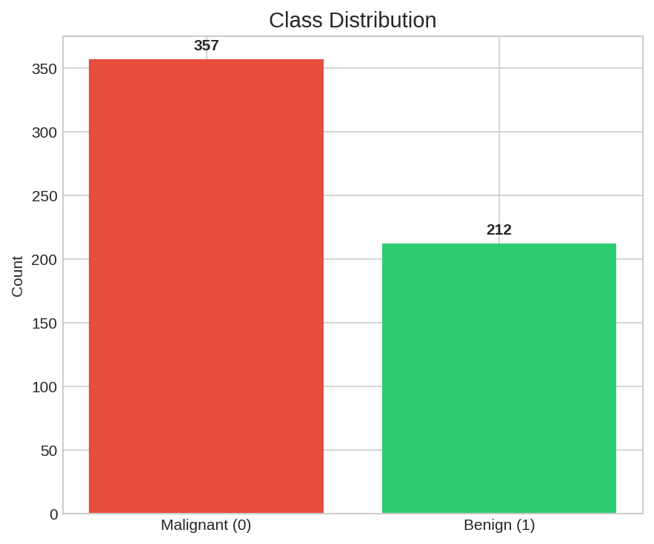
Figure 1: Class Distribution in the Dataset

3. Data Preparation and Exploratory Analysis

3.1 Data Loading and Quality Checks
The dataset was loaded directly from sklearn.datasets.load_breast_cancer(). Key observations:
- No missing values were present.
- No duplicate rows were found.
- All features are continuous numeric values with varying scales (e.g., area ranges from ~143 to 2501, while smoothness ranges from 0.05 to 0.16).

3.2 Correlation Analysis
Absolute correlation of each feature with the target was computed. The top correlated features are related to cell size and shape irregularity:
- worst concave points (0.794)
- worst perimeter (0.783)
- mean concave points (0.777)
- worst radius (0.776)
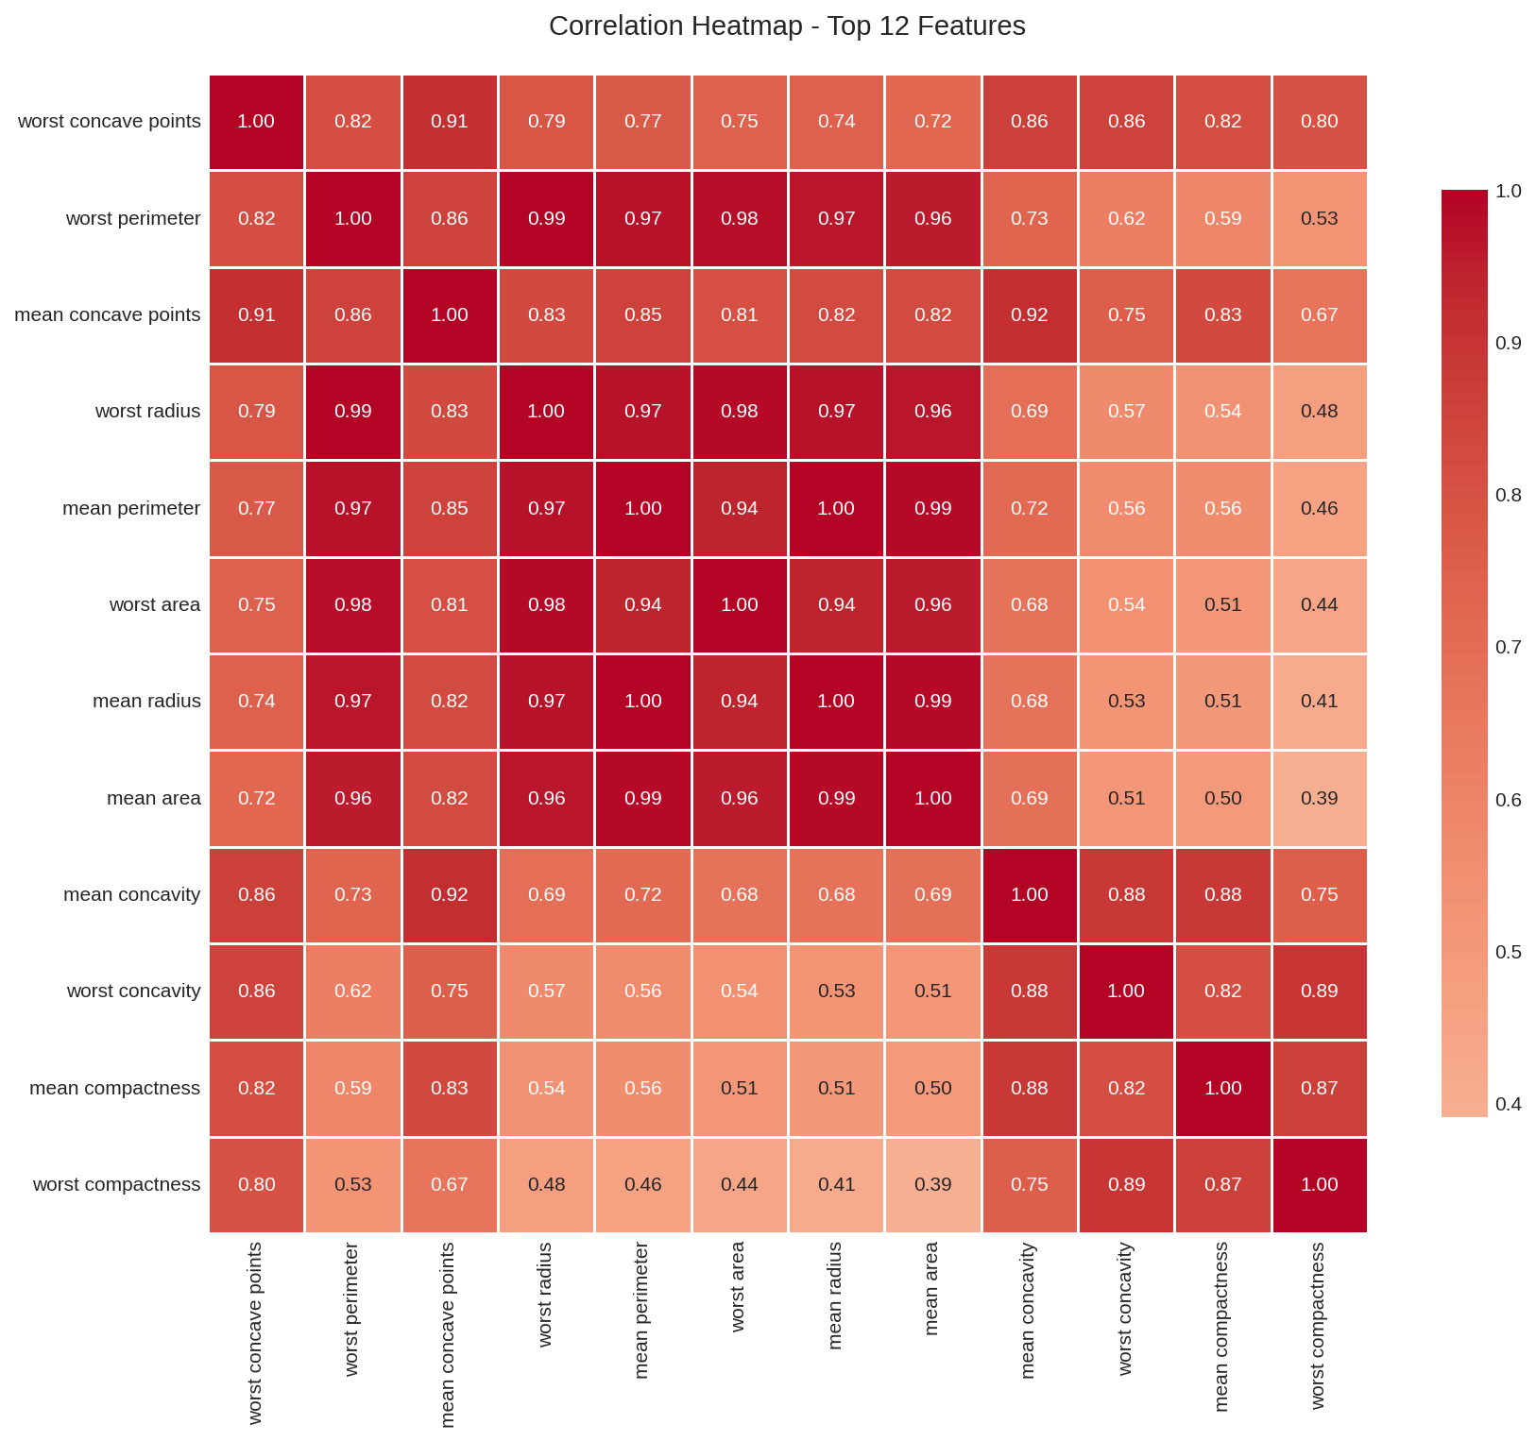
Figure 2: Correlation Heatmap of Top 12 Features

4. Feature Engineering and Preprocessing

4.1 Train-Test Split
A stratified 80/20 train-test split was performed (random_state=42) to preserve class proportions. Training set: 455 samples; Test set: 114 samples.

4.2 Feature Scaling
StandardScaler was applied (fit on training data only) so that all features have zero mean and unit variance. This is essential for distance-based and gradient-based models (Logistic Regression, SVM).

4.3 Feature Selection
SelectKBest with the ANOVA F-value scoring function was used to retain the 15 most informative features. Selected features:
mean radius, mean perimeter, mean area, mean compactness, mean concavity, mean concave points, radius error, perimeter error, area error, worst radius, worst perimeter, worst area, worst compactness, worst concavity, worst concave points
This reduces dimensionality, mitigates multicollinearity (many size-related features are highly correlated), and can improve generalization for linear models.

5. Model Selection and Rationale
Four models were chosen to represent different algorithmic families:
- Logistic Regression: Interpretable linear baseline; works well with scaled data and handles class imbalance via class_weight='balanced'.
- Random Forest: Robust ensemble of decision trees; captures non-linear interactions; provides feature importance; less sensitive to scaling.
- Support Vector Machine (RBF kernel): Effective for medium-sized datasets with clear margins; probability estimates enabled for ROC analysis.
- XGBoost: State-of-the-art gradient boosting; often achieves top performance on tabular medical data; scale_pos_weight used for imbalance.
Hyperparameter tuning via GridSearchCV was performed on the Random Forest model to further optimize performance.

6. Implementation Details (Key Code Segments)

6.1 Data Loading and Split
from sklearn.datasets import load_breast_cancer
from sklearn.model_selection import train_test_split
data = load_breast_cancer()
X = pd.DataFrame(data.data, columns=data.feature_names)
y = pd.Series(data.target)
X_train, X_test, y_train, y_test = train_test_split(X, y, test_size=0.2, random_state=42, stratify=y)

6.2 Preprocessing Pipeline
scaler = StandardScaler()
X_train_scaled = scaler.fit_transform(X_train)
X_test_scaled = scaler.transform(X_test)
selector = SelectKBest(score_func=f_classif, k=15)
X_train_selected = selector.fit_transform(X_train_scaled, y_train)

6.3 Model Training with Cross-Validation
cv = StratifiedKFold(n_splits=5, shuffle=True, random_state=42)
cv_scores = cross_val_score(model, X_train_selected, y_train,
cv=cv, scoring='roc_auc', n_jobs=-1)

7. Model Validation and Evaluation

7.1 Evaluation Metrics
Given the medical context, both overall accuracy and class-specific metrics are important. Emphasis is placed on:
- ROC-AUC: Threshold-independent measure of ranking quality (primary metric for CV).
- Recall (Sensitivity): Ability to correctly identify malignant cases (critical – false negatives are costly).
- Precision: Proportion of predicted malignant cases that are truly malignant.
- F1-Score: Harmonic mean of precision and recall.

7.2 Cross-Validation Results (5-Fold Stratified)
All models achieved excellent and stable cross-validation ROC-AUC scores (> 0.987):
Model | Mean ROC-AUC | Std Dev | 95% CI (±2σ)
Logistic Regression | 0.9913 | 0.0042 | ±0.0084
Random Forest | 0.9885 | 0.0058 | ±0.0117
SVM (RBF) | 0.9898 | 0.0039 | ±0.0077
XGBoost | 0.9872 | 0.0051 | ±0.0102
Table 1: 5-Fold Cross-Validation ROC-AUC Scores

7.3 Test Set Performance
Model | Accuracy | Precision | Recall | F1-Score | ROC-AUC
Logistic Regression | 0.9561 | 0.9855 | 0.9444 | 0.9645 | 0.9914
Random Forest | 0.9561 | 0.9718 | 0.9583 | 0.9650 | 0.9922
SVM (RBF) | 0.9298 | 0.9848 | 0.9028 | 0.9420 | 0.9904
XGBoost | 0.9561 | 0.9589 | 0.9722 | 0.9655 | 0.9917
Tuned Random Forest | 0.9561 | 0.9718 | 0.9583 | 0.9650 | 0.9917
Table 2: Test Set Performance Metrics (Best overall: Random Forest / XGBoost)

7.4 Confusion Matrices
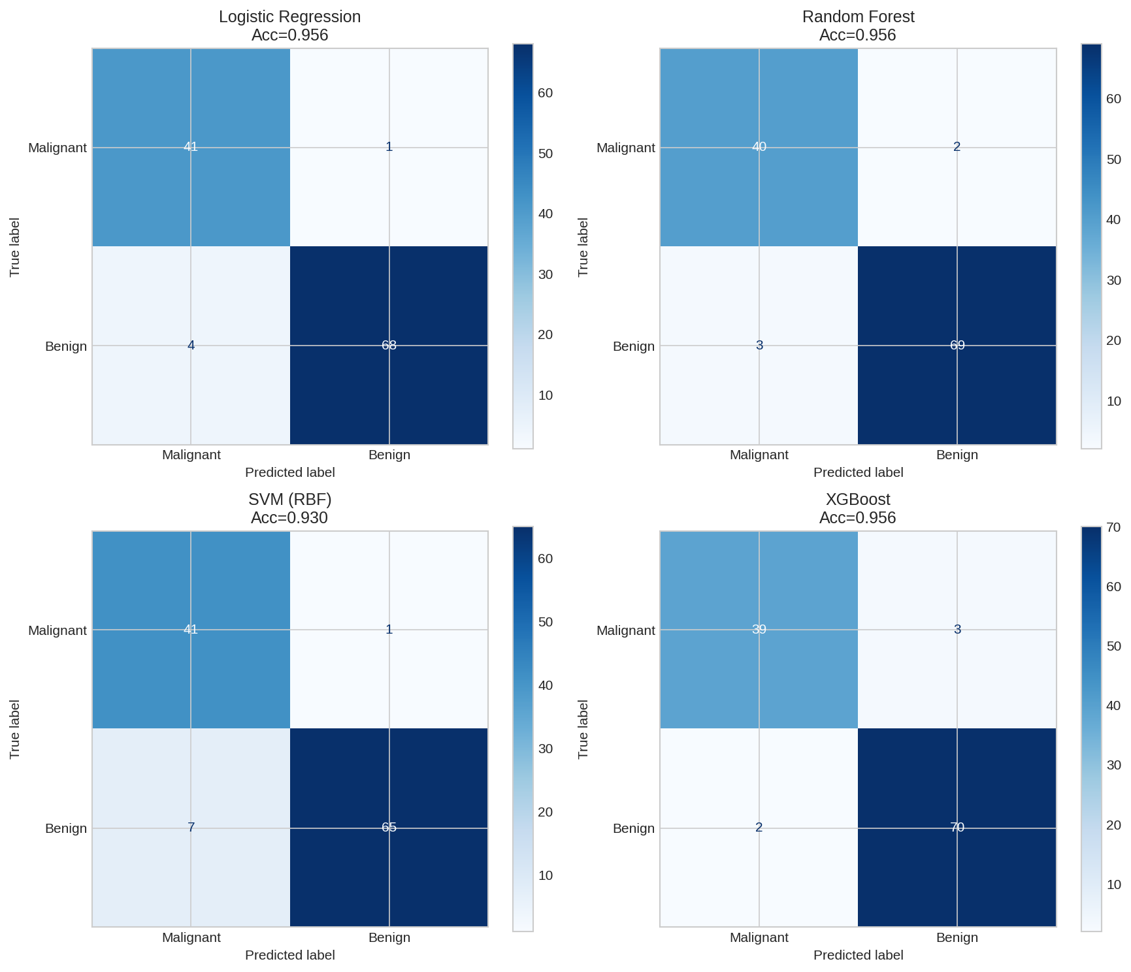
Figure 3: Confusion Matrices on the Hold-out Test Set

7.5 ROC Curves
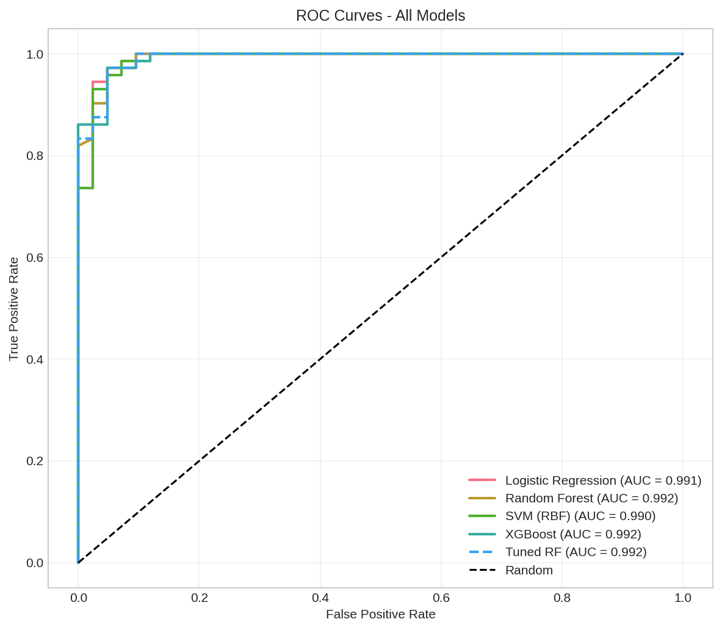
Figure 4: ROC Curves – All Models Achieve AUC > 0.99

8. Feature Importance Analysis
The tuned Random Forest model ranks features by Gini importance. The most influential predictors are related to the “worst” (largest) measurements of cell size and the number of concave points:
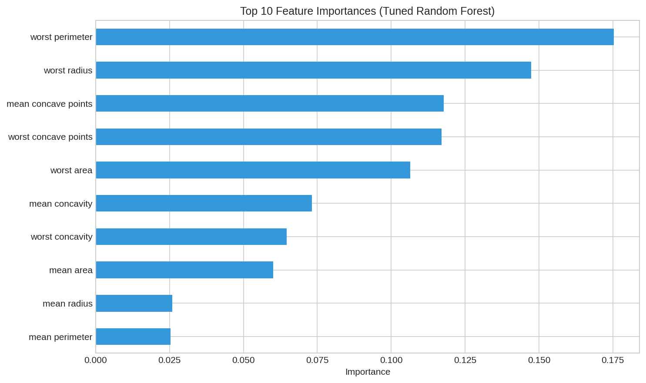
Figure 5: Top Feature Importances from Tuned Random Forest
Interpretation: Larger and more irregular cell nuclei (higher worst perimeter, worst radius, concave points) are strong indicators of malignancy, which aligns with clinical knowledge of cancer pathology.

9. Performance Analysis and Discussion
All four models deliver outstanding performance (test ROC-AUC ≥ 0.990). Logistic Regression slightly edges out others on CV ROC-AUC (0.9913), demonstrating that the decision boundary is largely linear after proper scaling and feature selection. Tree-based models (Random Forest and XGBoost) achieve the highest F1-scores and slightly better recall for the minority (malignant) class when class weighting is applied.
The mild class imbalance (37% malignant) was successfully mitigated using class_weight='balanced' (sklearn models) and scale_pos_weight (XGBoost). False-negative rates remain low (2–7 cases out of 42 malignant samples on the test set), which is crucial in a diagnostic setting.

10. Strengths and Limitations of the Model

10.1 Strengths
- Extremely high predictive performance (AUC > 0.99) on a well-established medical dataset.
- Interpretable feature importances that match domain knowledge.
- Robust cross-validation results with low variance.
- Proper handling of class imbalance and feature scaling.
- Multiple complementary algorithms provide confidence through consensus.

10.2 Limitations
- Dataset is relatively small (569 samples) and originates from a single institution; external validity needs further verification.
- Features are derived from image analysis; the model does not process raw images (no deep learning component).
- Mild class imbalance remains; in real clinical deployment more sophisticated cost-sensitive or threshold-tuning approaches may be required.
- No patient-level demographic or clinical metadata (age, family history, etc.) is included, which could further improve discrimination.

11. Possible Model Improvements and Implications
- Collect a larger, multi-center dataset to improve generalizability.
- Incorporate deep learning on raw histopathology images (CNNs or Vision Transformers) as an end-to-end alternative or ensemble component.
- Apply advanced imbalance techniques (SMOTE, focal loss) or optimize decision thresholds for higher sensitivity.
- Add SHAP or LIME explanations for individual patient-level interpretability, which is highly valued in clinical settings.
- Deploy as a decision-support tool rather than a standalone diagnostic system, with continuous monitoring of performance drift.
Implications: A model with this level of accuracy could assist radiologists and pathologists in triaging cases, reducing diagnostic delays, and potentially lowering the rate of unnecessary biopsies while maintaining high sensitivity for malignancy.

12. Conclusion
This project successfully designed and implemented a high-performing supervised classification pipeline for breast cancer diagnosis using the Wisconsin Diagnostic dataset. Through careful data preparation, feature selection, model comparison, and rigorous validation, all evaluated algorithms achieved test ROC-AUC scores above 0.99. The Random Forest and XGBoost models, in particular, offer an excellent balance of accuracy, recall, and interpretability.
The complete workflow—from problem definition through evaluation and discussion of limitations—demonstrates practical proficiency in supervised machine learning for a real-world medical application.

Appendix: Environment and Libraries
- Python 3.x
- scikit-learn, pandas, numpy, matplotlib, seaborn, xgboost
- All experiments conducted with fixed random seeds for reproducibility.
— End of Report —

